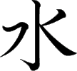
Meaning:
Onyomi: Kunyomi: Vocabulary:
Water
Sui [すい] Mizu [みず]
水道 - すいどう - suidou -
Water pipe
To check the strokes order click on the link or
search www.kanjiyes.com
★ It can represent the current of water
4 strokes

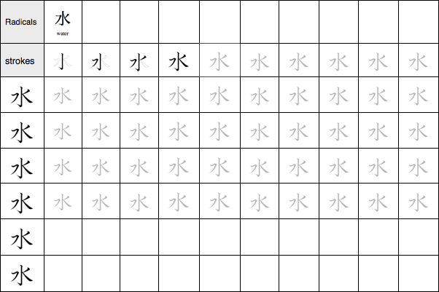


Meaning:
Onyomi: Kunyomi: Vocabulary:
Fire
Ka [か]
Hi [ひ]
火山 - かざん - kazan –
Volcano
To check the strokes order click on the link or
search www.kanjiyes.com
★ It looks like a camp fire with flames flying around.
4 strokes

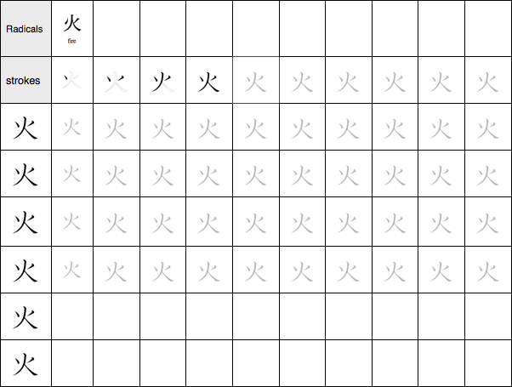

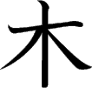
Meaning:
Onyomi: Kunyomi: Vocabulary:
Tree, wood
Boku/Moku [ぼく/もく] Ki/Ko [き/こ]
木曜日 - もくようび -
mokuyoubi – Thursday
To check the strokes order click on the link or
search www.kanjiyes.com
★ It is easy to remember since it looks like a tree
!
4 strokes

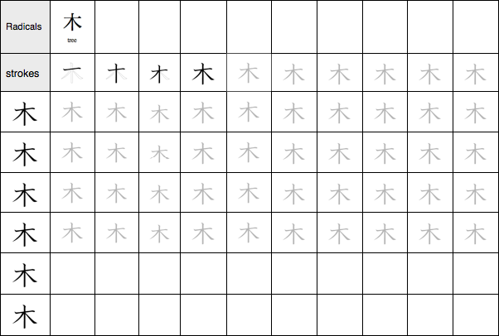

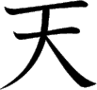
Meaning:
Onyomi: Kunyomi: Vocabulary:
Sky
Ten [てん]
Ame, Ama [あめ/あま]天気 - てんき - tenki – Weather
To check the strokes order click on the link or
search www.kanjiyes.com
★ Heaven is one (一) big (大) place !
4 strokes

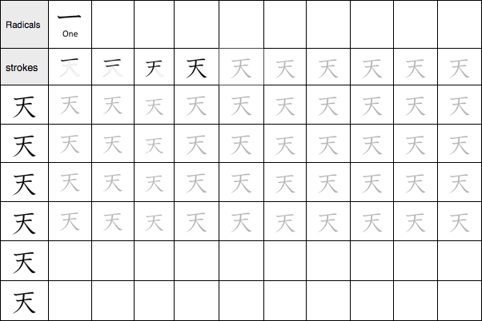

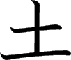
Meaning:
Onyomi: : Kunyomi: Vocabulary:
Earth, Ground
Do / To [ど/と] Tsuchi [つち]
土 - つち - tsuchi – Earth
To check the strokes order click on the link or
search www.kanjiyes.com
★ It looks like a cross on a grave buried
in the ground
3 strokes

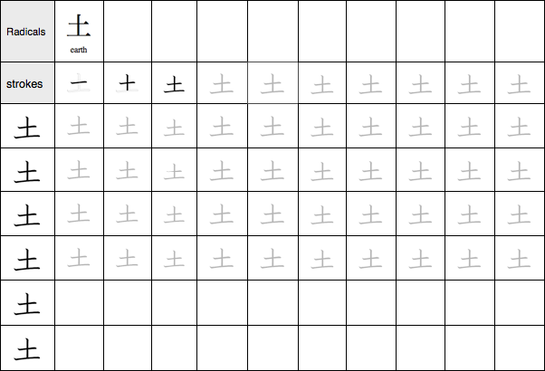

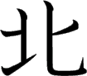
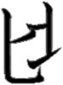
Meaning:
Onyomi: Kunyomi: Vocabulary:
North
Hoku [ほく] Kita [きた]
北米 - ほくべい - hokubei -
North America
To check the strokes order click on the link or search www.kanjiyes.com
★ When putting it together it looks like a ladder to go up NORTH
5 strokes

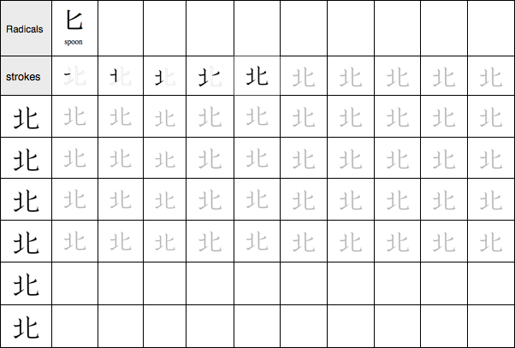

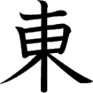
Meaning:
Onyomi: Kunyomi: Vocabulary:
East
Tou [とう] Higashi [ひがし]
東京 - とうきょう - toukyou -
Tokyo
To check the strokes order click on the link or
search www.kanjiyes.com
★ The sun (日) rise behind a tree (木) on the East.
8 strokes

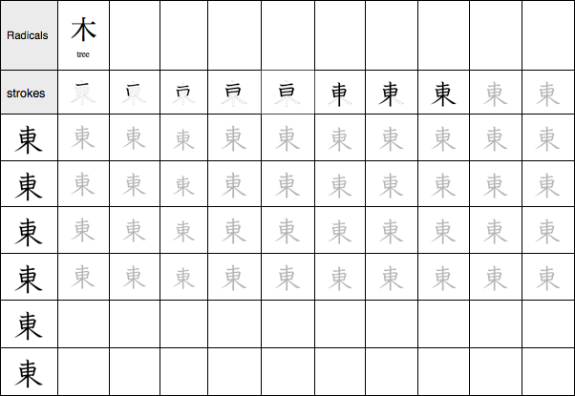

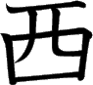
Meaning:
Onyomi: Kunyomi: Vocabulary:
West
Sei /Sai [せい/さい] Nishi [にし]
西暦 - せいれき - seireki -
Christian era
To check the strokes order click on the link or
search www.kanjiyes.com
★ The upper part looks like the Greek symbol π
(Pi). Greek is a western country
6 strokes

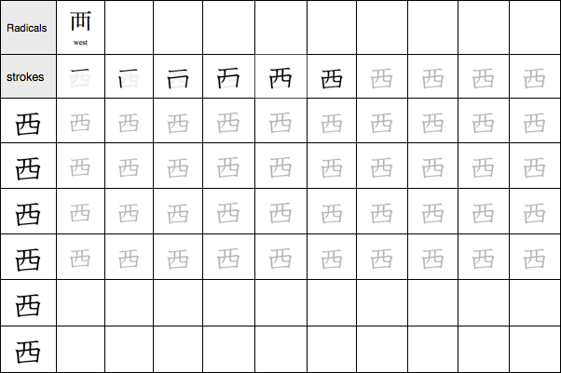

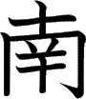
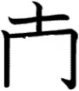
Meaning:
Onyomi: Kunyomi: Vocabulary:
South
Nan [なん] Minami [みなみ]
南米 - なんべい - nanbei -
South America
To check the strokes order click on the link or
search www.kanjiyes.com
★ In the South there are many believers who give lots of money(¥) to the churches
9 strokes

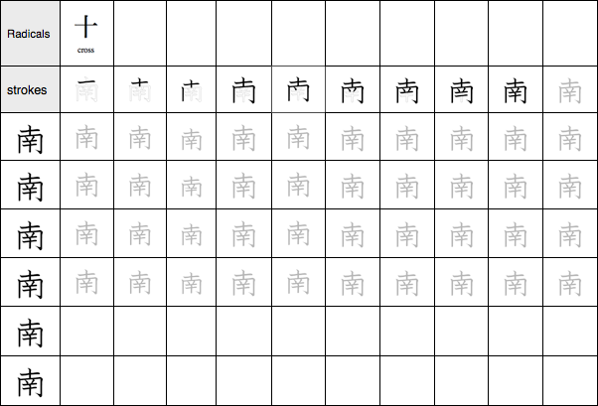

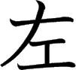
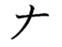
Meaning:
Onyomi: Kunyomi: Vocabulary:
Left
Sa [さ]
Hidari [ひだり]
左折 - させつ - sasetsu - To
turn left
To check the strokes order click on the link or
search www.kanjiyes.com
★ The hand ( ) is on the left of something working (工)
5 strokes

