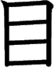
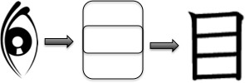
Meaning:
Onyomi: Kunyomi: Vocabulary:
Eye
Moku [もく] Me [め]
目的 - もくてき - mokuteki -
purpose, goal
To check the strokes order click on the link or
search www.kanjiyes.com
★
5 strokes

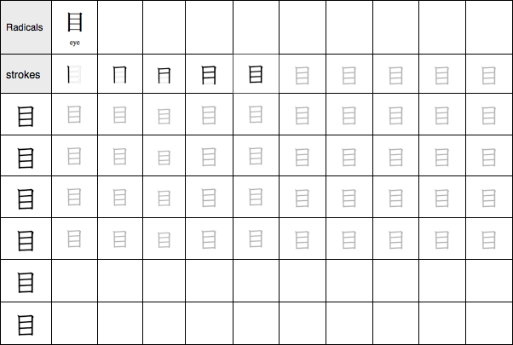


Meaning:
Onyomi: Kunyomi: Vocabulary:
Mouth
Kou/Ku [こう/く] Kuchi [くち]
火口 - かこう - kakou - Crater
of a volcano
To check the strokes order click on the link or
search www.kanjiyes.com
★ It looks like a mouth wide open
3 strokes

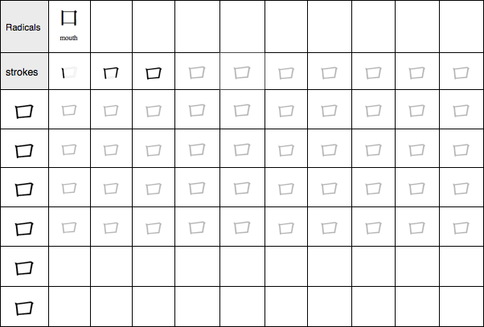

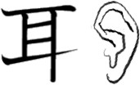
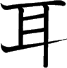
Meaning:
Onyomi: Kunyomi: Vocabulary:
Ear
Ji [じ]
Mimi [みみ]
耳孔 - じこう - jikou - Earhole
To check the strokes order click on the link or
search www.kanjiyes.com
★ It looks a little like an ear with a hole in the
middle and one part sticking out down
6 strokes

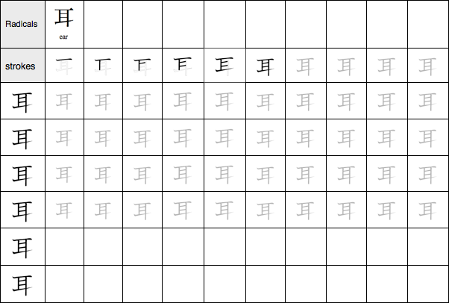

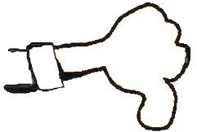
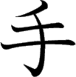
Meaning:
Onyomi: Kunyomi: Vocabulary:
Hand
Shu [しゅ] Te [て]
空手 - からて - karate - Karate
To check the strokes order click on the link or
search www.kanjiyes.com
★ It is a simplified Hand drawing giving a thumb down
4 strokes

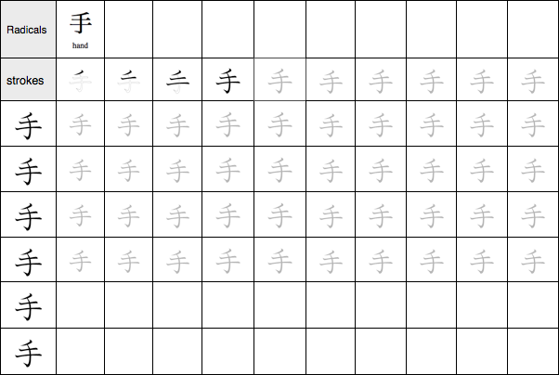

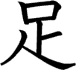
Meaning:
Onyomi:
Kunyomi:
Vocabulary:
Foot, to be sufficient, to add
Soku [そく] Ashi/Ta(riru)/Ta(su) [あし/た (りる)/た(す)]
満足 - まんぞく - manzoku -
Satisfaction
To check the strokes order click on the link or
search www.kanjiyes.com
★ It looks like a cartoon character running with his huge Feet
7 strokes

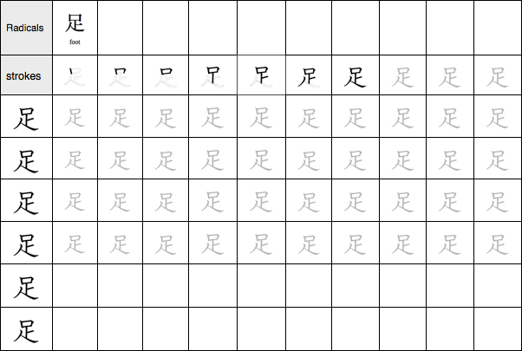

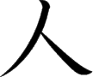
Meaning:
Onyomi: Kunyomi: Vocabulary:
Person
Jin / Nin [じん/にん] Hito [ひと]
人口 - じんこう - jinkou -
Population
To check the strokes order click on the link or
search www.kanjiyes.com
★ It looks like a Man standing with his legs spread.
2 strokes

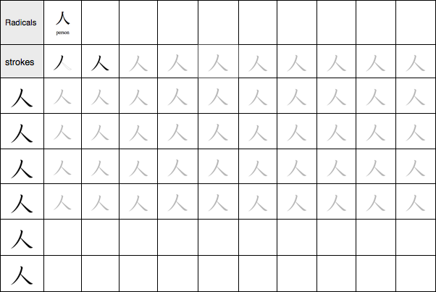

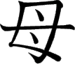
Meaning:
Onyomi: Kunyomi: Vocabulary:
Mother
Bo [ぼ] Haha [はは]
祖母 - そぼ - sobo –
Grandmother
To check the strokes order click on the link or
search www.kanjiyes.com
★ It is suppose to represent a Mother’s breast.
5 strokes

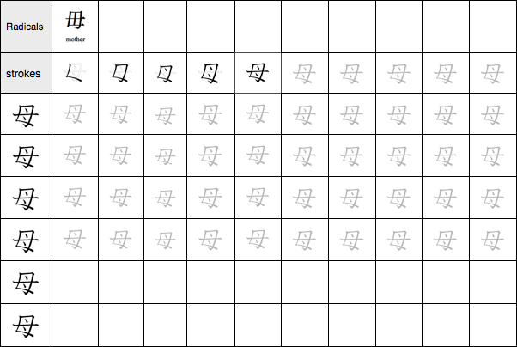

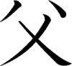
Meaning:
Onyomi: Kunyomi: Vocabulary:
Father
Fu [ふ] Chichi [ちち]
祖父 - そふ - sofu -
Grandfather
To check the strokes order click on the link or
search www.kanjiyes.com
★ It looks like the shape of a man with his hands up because he became a Father.
4 strokes

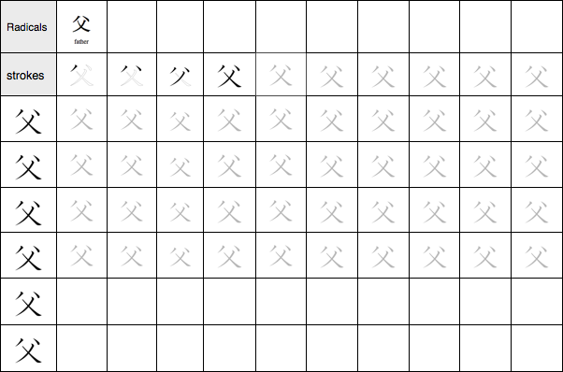

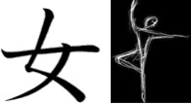
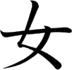
Meaning:
Onyomi: Kunyomi: Vocabulary:
Woman, female
Jo [じょ]
Onna / Me [おんな/め]女性 - じょせい - josei - Female
To check the strokes order click on the link or
search www.kanjiyes.com
★ It looks like a ballerina
3 strokes

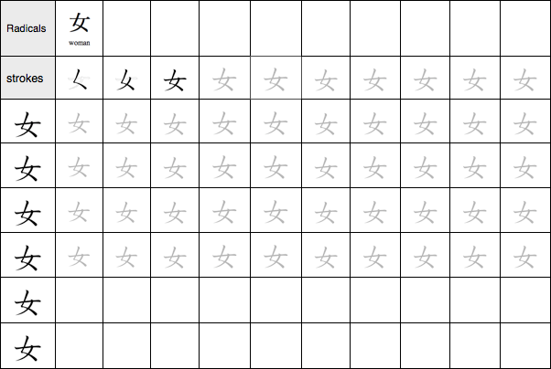

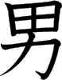
Meaning:
Onyomi: Kunyomi: Vocabulary:
Man, Male
Dan/Nan [だん/なん]
Otoko [おとこ]
男性 - だんせい - dansei - Male
To check the strokes order click on the link or
search www.kanjiyes.com
★ The upper part means rice field while the lower part means strength thus you need to be a strong Man to work in the field.
7 strokes

