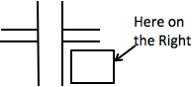
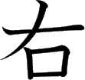
Meaning:
Onyomi: Kunyomi: Vocabulary:
Right
U / Yuu [う / ゆう] Migi [みぎ]
右岸 - うがん - ugan - Right
Shore
To check the strokes order click on the link or
search www.kanjiyes.com
★ On a map the restaurant
(mouth 口) is on the right of the intersection
5 strokes

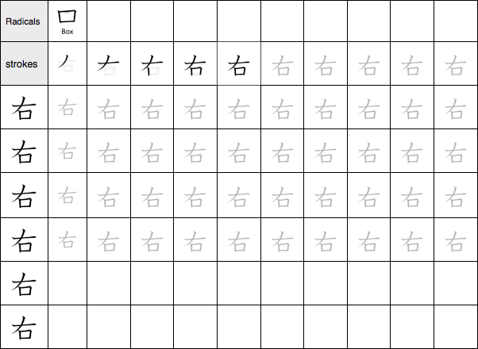

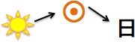

Meaning:
Onyomi: Kunyomi: Vocabulary:
Day, Sun
Nichi/Jitsu [にち/じつ] Hi/Ka [ひ/か]
日本 - にほん - nihon - Japan
To check the strokes order click on the link or
search www.kanjiyes.com
★
4 strokes

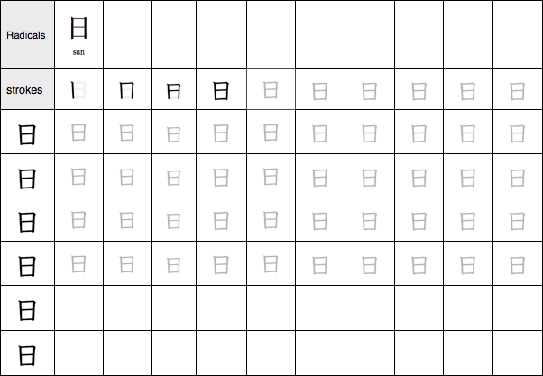

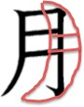
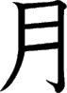
Meaning:
Onyomi: Kunyomi: Vocabulary:
Month, moon
Getsu/Gatsu [げつ/がつ] Tsuki [つき]
満月 - まんげつ - mangetsu -
Full moon
To check the strokes order click on the link or
search www.kanjiyes.com
★ It looks like a quarter of the moon
4 stroke

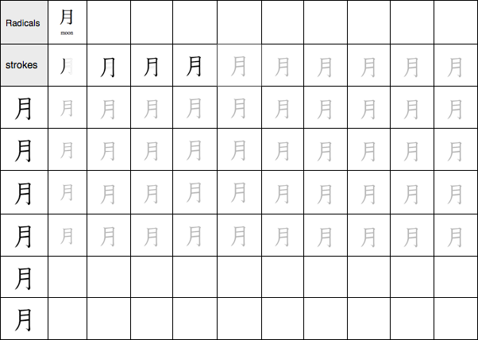

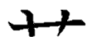
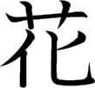
Meaning:
Onyomi: Kunyomi: Vocabulary:
Flower, blossom
Ka [か] Hana [はな]
花瓶 - かびん - kabin - Vase
To check the strokes order click on the link or
search www.kanjiyes.com
★ Weed (
flowers (花)
) sometime changes (化) into
7 strokes

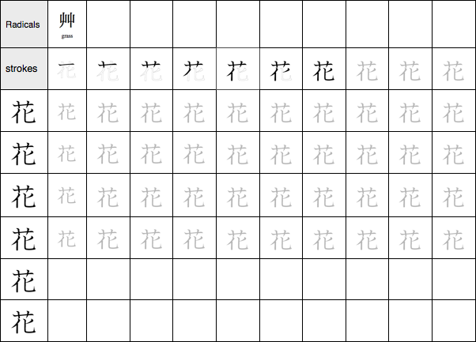

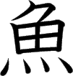
Meaning:
Onyomi: Kunyomi: Vocabulary:
Fish
Gyo [ぎょ]
Sakana / Uo [さかな/うお]金魚 - きんぎょ - kingyo – Goldfish
To check the strokes order click on the link or
search www.kanjiyes.com
★ It looks like a fish swimming upward.
10 strokes

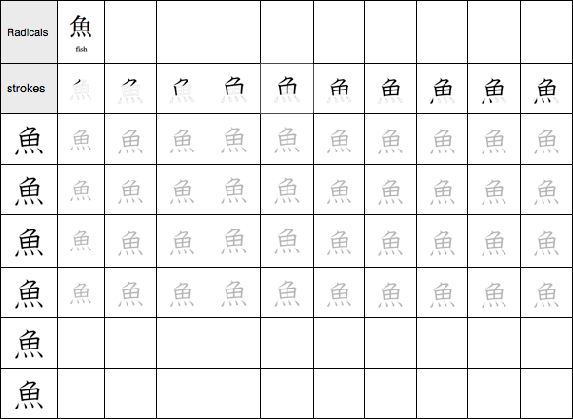

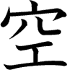
Meaning:
Onyomi: Kunyomi: け Vocabulary:
Sky, to become free, empty
Kuu [くう] Sora/A(keru)/Kara [そら/あ(る)/から]
空港 - くうこう - kuukou -
Airport
To check the strokes order click on the link or
search www.kanjiyes.com
★ Working (工) in a hole (穴) makes you feel empty.
8 strokes

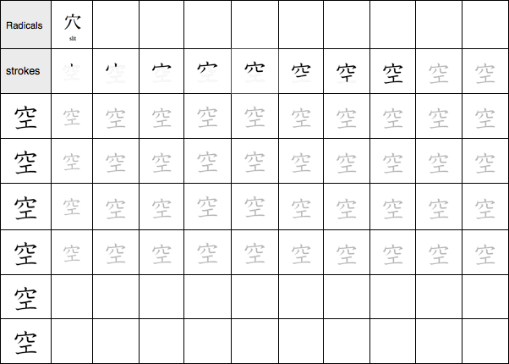


Meaning:
Onyomi: Kunyomi: Vocabulary:
Mountain
San [さん] Yama [やま]
山羊 - やぎ - yagi - A goat
To check the strokes order click on the link or
search www.kanjiyes.com
★ This Kanji has the shape of the mountain it
stands for.
3 strokes

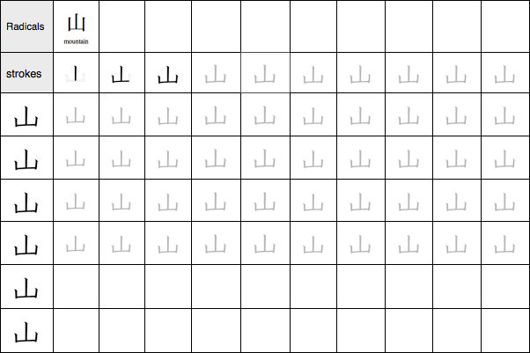


Meaning:
Onyomi: Kunyomi: Vocabulary:
Shogun of
shogunate.
River
Sen [せん]
Kawa [かわ]
徳川 - とくがわ - Tokugawa -
Togugawa (Ieyasu) first
the Tokugawa
To check the strokes order click on the link or
search www.kanjiyes.com
★ The three strokes represents the current of a river.
3 strokes

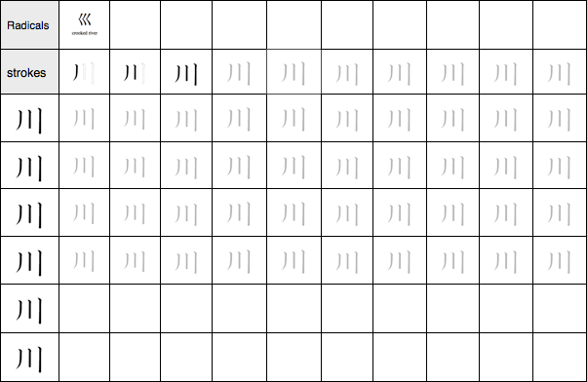

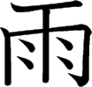
Meaning:
Onyomi: Kunyomi: Vocabulary:
Rain
U [う]
Ame [あめ]
梅雨 - つゆ - tsuyu - Rainy
season
To check the strokes order click on the link or
search www.kanjiyes.com
★ It looks like rain drops hitting a window
8 strokes

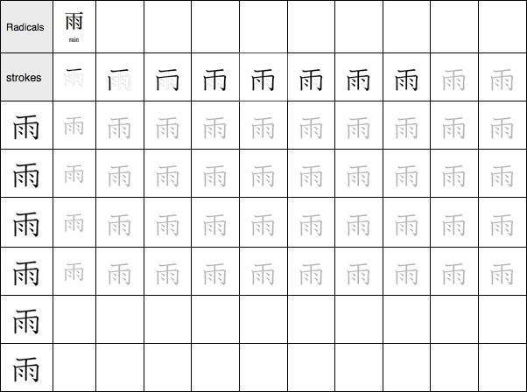

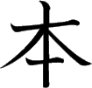
Meaning:
Onyomi: Kunyomi: Vocabulary:
Book, Source
Hon [ほん] Moto [もと]
本物 - ほんもの - honmono –
Original
To check the strokes order click on the link or
search www.kanjiyes.com
★ Books are made from trees cut at their bottom (hence the bottom line)
5 stroke

