Master the First 103 Kanji:
Essential Characters for Japanese Beginners

Build your Japanese literacy foundation with the first 103 kanji officially taught in Japanese schools. These characters cover:

Core vocabulary: 人 (person), 日 (sun/day), 水 (water), 火 (fire), 山 (mountain)

Radical components: Learn 35+ radicals like ⼈(human) and ⽊(tree)

Real-world coverage: Appear in 50%+ of daily written materials

Each character includes:

✓ Stroke order animations

✓ On/Kun readings (音読み・訓読み)

✓ Vocabulary compounds (e.g., 火山 = volcano)

✓ Printable practice sheets

Based on Japan’s Grade 1 Kyōiku Kanji curriculum, this set aligns with JLPT N5 requirements. Master stroke patterns and radicals to accelerate future kanji learning. Includes WaniKani and RTK (Remembering the Kanji) compatibility tips.

www.kanjiyes.com

About this book

This book helps beginners of the Japanese language memorizing and writing the first 103 kanji characters required for the Japanese Language Proficiency Test N5.

Each kanji is represented on one page featuring:

• Its meaning
• The onyomi and kunyomi readings
• Vocabulary that includes this kanji
• The number of strokes and the stroke order with a link to the
www.kanjiyes.com/kanji/ website to video showing the stroke
order
• The radicals (components) the kanji consists of
• A hint to help memorizing the kanji
• A grid to exercise writing

You can print each page on your own printer and repeat the writing exercises as often as you like.

Copyright
This book is a service to the community of Japan fans.
THERE IS NO COPYRIGHT!

Please feel free to share it with your friends and other students of Japanese.

About us
NIHON ICHIBAN is a social business to promote Japanese culture and lifestyle in the world. With our free websites we serve a community of more than 92,000 fans of Japan in more than 150 countries.

www.kanjiyes.com/kanji

The Japanese writing system
The Japanese written language consists of a combination of three types of characters. To a lesser extend it nowadays also uses some Latin alphabet for abbreviations and numbers.

Kanji (漢字)
Kanji originally came from China to Japan. The term “kanji” literally means “Han characters” or “Chinese characters” and it is identical to the characters in China to describe their writing.

Kanji are mainly used to describe names and nouns. When used in verbs and adjectives they mostly are written in combination with hiragana. Most sentences include kanji as well as hiragana.

Japanese dictionaries list around 10,000 kanji. The Japanese government limited the kanji used in official publications to the 1945 touyou kanji with about 4000 readings. The Japanese Language Proficiency Test (JLPT) is based on these 1945 touyou kanji.
A Japanese with average education knows around 3000 kanji and it is estimated that around 4000 kanji are used in Japanese literature.
- Hiragana (平仮名)
Hiragana is a phonetic alphabet that was developed in the ninth century to simplify writing. It nowadays is mainly used for native Japanese words. Hiragana are derived from more complex kanji and each hiragana represents a syllable. A total of 46 hiragana are used in contemporary Japanese writing.
List of the 46 hiragana and their 25 diagritics (with ゛or ゜)

A | I | U | E | O
あ (a) | い (i) | う (u) | え (e) | お (o)
か (ka)  が (ga) | き (ki)  ぎ (gi) | く(ku)  ぐ (gu) | け (ke)  げ (ge) | こ (ko)  ご (go)
さ (sa)  ざ (za) | し (shi)  じ (ji) | す (su)  ず (zu) | せ (se)  ぜ (ze) | そ (so)  ぞ (zo)
た (ta)  だ (da) | ち (chi)  ぢ (ji) | つ (tsu)  づ (zu) | て (te)  で (de) | と (to)  ど (do)
な (na) | に (ni) | ぬ (nu) | ね (ne) | の (no)

A | I | U | E | O
は (ha)  ば (ba)  ぱ (pa) | ひ (hi)  び (bi)  ぴ (pi) | ふ (fu)  ぶ (bu)  ぷ (pu) | ~ (he)  ベ (be)  ぺ (pe) | ほ (ho)  ぼ (bo)  ぽ (po)
ま (ma) | み (mi) | む (mu) | め (me) | も (mo)
や (ya) |  | ゆ (yu) |  | よ (yo)
ら (ra) | り (ri) | る (ru) | れ (re) | ろ (ro)
わ (wa) |  |  |  | を (o/wo)
ん (n)

The combination of some of these hiragana is used to express a few additional sounds used in Japanese. The first character is written in normal size whereas the second character is written a little bit smaller. These combinations are called digraphs.

List of 21 hiragana digraphs and their 15 diagritics
YA | YU | YO
きゃ (kya)  ぎゃ (gya) | きゅ (kyu)  ぎゅ (gyu) | きょ (kyo)  ぎょ (gyo)
しゃ (sha)  じゃ (ja) | しゅ (shu)  じゅ (ju) | しょ (sho)  じょ (jo)
ちゃ (cha)  ぢゃ (ja) | ちゅ (chu)  ぢゅ (ju) | ちょ (cho)  ぢょ (jo)
にゃ (nya) | にゅ (nyu) | にょ (nyo)
ひゃ (hya)びゃ (bya)ぴゃ (pya) | ひゅ (hyu)びゅ (byu)ぴゅ (pyu) | ひょ (hyo)びょ (byo)ぴょ (pyo)
みゃ (mya) | みゅ (myu) | みょ (myo)
りゃ (rya) | りゅ (ryu) | りょ (ryo)

- Katakana (片仮名)
Katakana also is a phonetic alphabet covering the same syllable as hiragana and it therefore also has 46 different characters. It is mainly used for foreign loanwords and sometimes to replace kanji or hiragana for emphasis. Katakana were developed in the ninth century and are also derived from more complex kanji.

List of the 46 basic katakana and their 25 diagritics (with ゛or ゜)

A | I | U | E | O
ア (a) | イ (i) | ウ (u) | エ (e) | オ (o)
カ (ka)  ガ (ga) | キ (ki)  ギ (gi) | ク (ku)  グ (gu) | ケ (ke)  ゲ (ge) | コ (ko)  ゴ (go)
サ (sa)  ザ (za) | シ (shi)  ジ (ji) | ス (su)  ズ (zu) | セ (se)  ゼ (ze) | ソ (so)  ゾ (zo)
タ (ta)  ダ (da) | チ (chi)  ヂ (ji) | ツ (tsu)  ヅ (zu) | テ (te)  デ (de) | ト (to)  ド (do)
ナ (na) | ニ (ni) | ヌ (nu) | ネ (ne) | ノ (no)
ハ (ha)  バ (ba)  パ (pa) | ヒ (hi)  ビ (bi)  ピ (pi) | フ (fu)  ブ (bu)  プ (pu) | ~ (he)  ベ (be)  ペ pe) | ホ (ho)  ボ (bo)  ポ(po)
マ (ma) | ミ (mi) | ム (mu) | メ (me) | モ (mo)
ヤ (ya) |  | ユ (yu) |  | ヨ (yo)
ラ (ra) | リ (ri) | ル (ru) | レ (re) | ロ (ro)
ワ (wa) |  |  |  | ヲ (o/wo)
ン (n)

As with hiragana there also are combinations to express the other sounds required for the Japanese language.

List of 21 katakana digraphs and their 15 diagritics
YA | YU | YO
キャ (kya)  ギャ (gya) | キュ (kyu)  ギュ (gyu) | キョ (kyo)  ギョ (gyo)
シャ (sha)  ジャ (ja) | シュ (shu)  ジュ (ju) | ショ (sho)  ジョ (jo)
チャ (cha)  ぢゃ (ja) | チュ (chu)  ヂュ (ju) | チョ (cho)  ヂョ (jo)
ニャ (nya) | ニュ (nyu) | ニョ (nyo)

YA | YU | YO
ヒャ (hya)ビャ (bya)ピャ (pya) | ヒュ (hyu)ビュ (byu)ピュ (pyu) | ヒョ (hyo)ビョ (byo)ピョ (pyo)
ミャ (mya) | ミュ (myu) | ミョ (myo)
リャ (rya) | リュ (ryu) | リョ (ryo)

These 46 katakana and their variations are sufficient to express all sounds used for Japanese words. In order to get closer to the pronunciation of foreign words, a list of not so common extended katakana is used.

List of extended katakana
A | I | U | E | O
 | イィ (yi) |  | イェ (ye)
ウァ (wa) | ウィ (wi) | ウゥ (wu) | ウェ (we) | ウォ (wo)
ヴァ (va) | ヴィ (vi) | ヴ (vu) | ヴェ (ve) | ヴォ (vo)
 |  |  | ヴィェ (vye)
 |  |  | キェ (kye)
 |  |  | ギェ (gye)
クァ (kwa) | クィ(kwi) |  | クェ (kwe) | クォ (kwo)
グァ (gwa) | グィ (gwi) |  | グェ (gwe) | グォ (gwo)
 |  |  | シェ (she)
 |  |  | ジェ (je)
 | スィ (si)
 | ズィ (zi)
 |  |  | チェ (che)
ツァ (tsa) | ツィ (tsi) |  | ツェ (tse) | ツォ (tso)
 | ティ (ti) | テゥ (tu)
 | ディ (di) | デゥ (du)
 |  |  | ニェ (nye)
 |  |  | ヒェ (hye)
 |  |  | ビェ (bye)

A | I | U | E | O
 |  |  | ピェ (pye)
ファ (fa) | フィ (fi) |  | フェ (fe) | フォ (fo)
 |  |  | フィェ (fye)
 |  | ホゥ (hu)
 |  |  | ミェ (mye)
 |  |  | リェ (rye)
ラ゜(la) | リ゜(li) | ル゜(lu) | レ゜(le) | ロ゜(lo)

Writing a Japanese text

It is possible to write everything in hiragana or katakana since both scripts cover the entity of sounds of the Japanese language, although this is not very practical due to the high number of words having the same pronunciation but different meanings.

All characters are written one by one and in the same size. There are no spaces between different words, which feels a little bit unusual for most foreigners. It takes time to get used to this and easily distinguish different words.
It is important to write the strokes in the correct order and directions to give the characters the right shape. The reason why becomes obvious when practicing with a brush pen1 , which is very much recommended for beginners.

Japanese writing is made in two directions. Horizontal writing (yokogaki) is from the left to the right as in western style. Traditional writing (tategaki) is vertical starting from the right top and ending at the left bottom. A book printed in tategaki opens from what Westerners would call the back, while a book printed in yokogaki opens from what traditionally in Japan would have been considered the back.2

1 A brush pen is a pen with a brush instead of a brush instead of the nib. You can get them in some Japanese shops or via mail order.
2 Wikipedia, Japanese writing system

Meaning:
Onyomi: Kunyomi: Vocabulary:
One
Ichi / Itsu [いち/いつ] Hito [ひと]
一口 - ひとくち - hitokuchi -
One bite
To check the strokes order click on the link www.kanjiyes.com
★ 一 is just one stroke
1 stroke

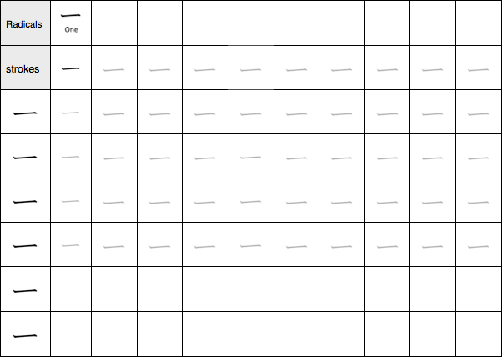

Master 2,136 Joyo Kanji with our free encyclopedia! Learn stroke order, meanings (火=fire, 死=death), and translation. WaniKani alternative with radical breakdowns. Practice writing kanji symbols & convert to hiragana. Download PDF worksheets now!
www.kanjiyes.com
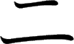
Meaning:
Onyomi: Kunyomi: Vocabulary:
Two
Ni [に] Futa [ふた]
二人 - ふたり - futari - Two
persons
To check the strokes order click on the link www.kanjiyes.com
★ 二 is made of two strokes 一 + 一 = 二
1 + 1 = 2
2 strokes

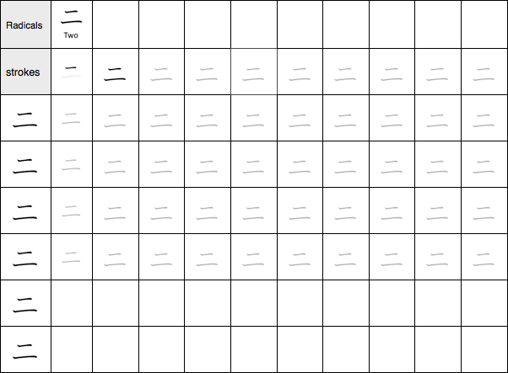

Master 2,136 Joyo Kanji with our free encyclopedia! Learn stroke order, meanings (火=fire, 死=death), and translation. WaniKani alternative with radical breakdowns. Practice writing kanji symbols & convert to hiragana. Download PDF worksheets now!
www.kanjiyes.com
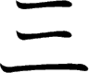
Meaning:
Onyomi: Kunyomi: Vocabulary:
Three
San [さん]
Mitsu / Mi- [みつ/みっ]
3日 - みっか - mikka - The 3rd
To check the strokes order click on the link www.kanjiyes.com
★ 三 is the result of 一 + 二
1 + 2 = 3
3 strokes

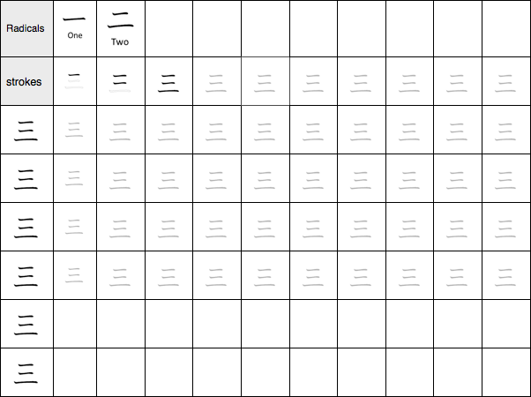

Master 2,136 Joyo Kanji with our free encyclopedia! Learn stroke order, meanings (火=fire, 死=death), and translation. WaniKani alternative with radical breakdowns. Practice writing kanji symbols & convert to hiragana. Download PDF worksheets now!
www.kanjiyes.com

