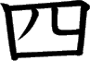
Meaning:
Onyomi: Kunyomi: Vocabulary:
Four
Shi [し]
Yo / Yu / Yon [よ/ゆ/よん]
四季 - しき - shiki - The 4
seasons
To check the strokes order click on the link or
search www.kanjiyes.com
★ There are four sides to a square
5 strokes

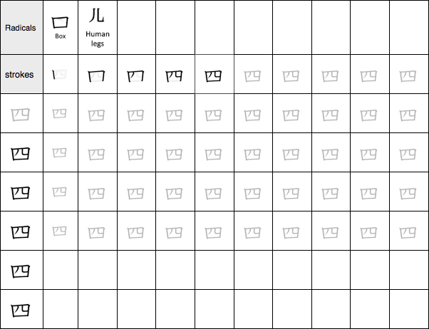

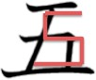
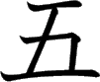
Meaning:
Onyomi: Kunyomi: Vocabulary:
Five
Go [ご] Itsu [いつ]
五つ - いつつ - itsutsu - Five
(ordinal number)
To check the strokes order click on the link or
search www.kanjiyes.com
★ It looks like the number 5
4 strokes

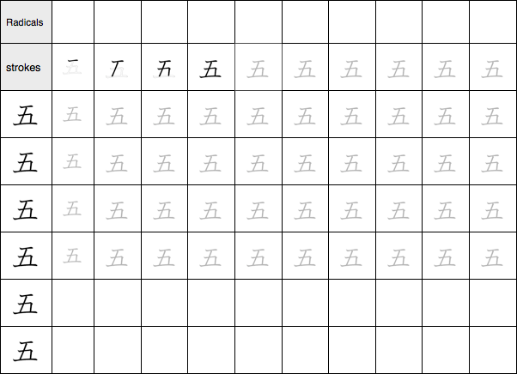

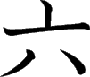
Meaning:
Onyomi: Kunyomi: Vocabulary:
Six
Roku [ろく]
Mu/Mut/Mui [む/むっ/むい]六つ - むっつ - muttsu - Six (ordinal number)
To check the strokes order click on the link or
search www.kanjiyes.com
★ 6 can be written VI if you turn them
around you get 六
4 strokes

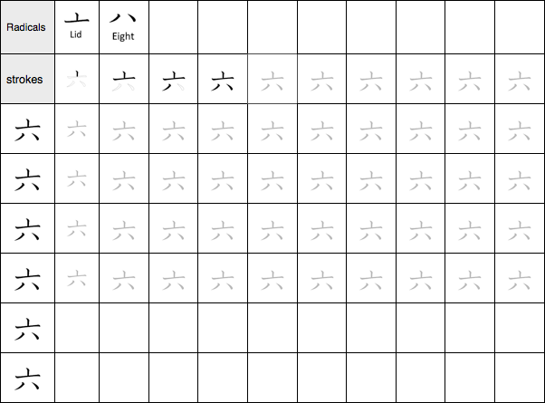

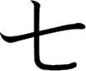
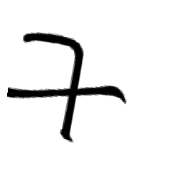
Meaning:
Onyomi: Kunyomi: Vocabulary:
Seven
Shichi [しち] Nana/Nano [なな/なの]
七月 – しちがつ – shichigatsu
- July
To check the strokes order click on the link or
search www.kanjiyes.com
★ It is a 7 inverted
2 strokes

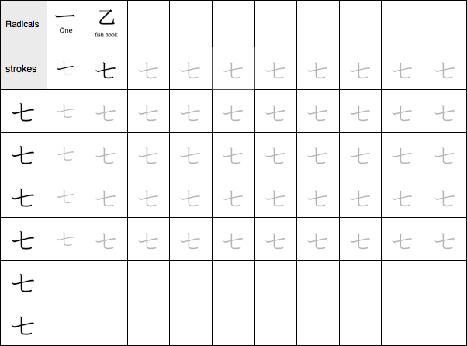

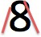
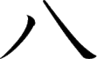
Meaning:
Onyomi: Kunyomi: Vocabulary:
Eight
Hachi [はち]
Yat/Ya/You [やっ/や/よう]
八つ - やっつ - Yattsu – Eight
(ordinal number)
To check the strokes order click on the link or
search www.kanjiyes.com
★ When following the simple shape of the 8 you get 八
2 strokes

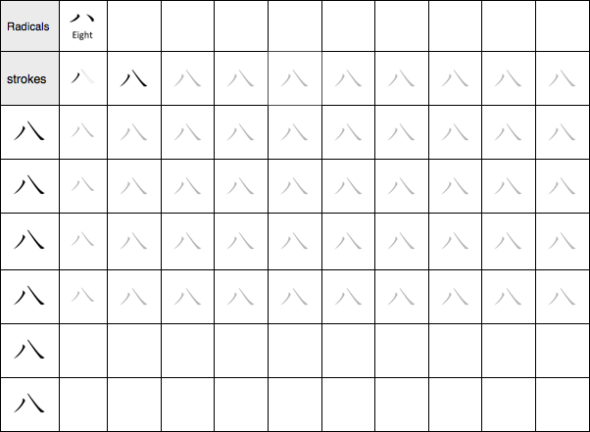

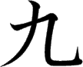
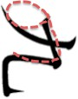
Meaning:
Onyomi: Kunyomi: Vocabulary:
Nine
Kyuu/Ku [きゅう/く] Kokono [ここの]
九日 - ここのか - Kokonoka - The 9th
Code NIHONGO ICHIBAN: 4E5D
To check the strokes order click on the link or search www.kanjiyes.com
★ You can see the shape of a 9
with a little imagination
2 strokes

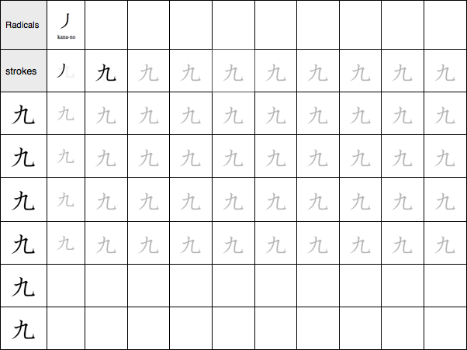

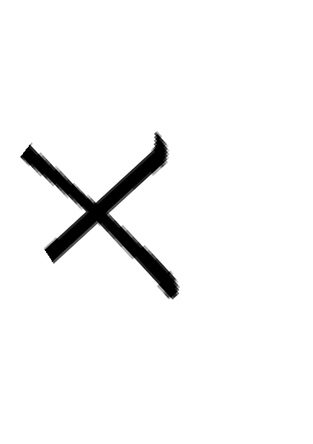
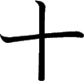
Meaning:
Onyomi: Kunyomi: Vocabulary: 10th
Ten
Juu/Ji [じゅう/じ]
Too [とお]
十日 - とおか - Tooka – The
To check the strokes order click on the link or
search www.kanjiyes.com
★ 10 can be written X
2 strokes

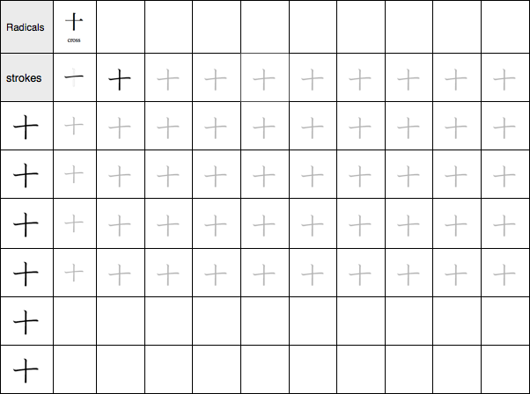

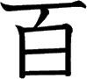
Meaning:
Onyomi: Kunyomi: Vocabulary:
Hundred
Hyaku [ひゃく]
/
百貨店 - ひゃっかてん - Hyakkaten - A mall
To check the strokes order click on the link or
search www.kanjiyes.com
★
100 ->
I00
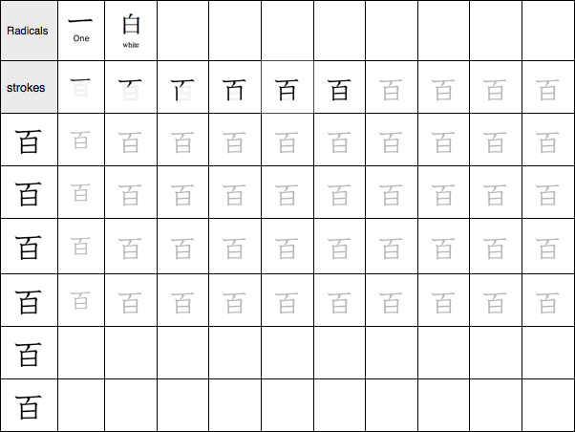
6 strokes

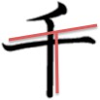
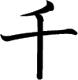
Meaning:
Onyomi: Kunyomi: Vocabulary: nisenen
Thousand
Sen [せん] Chi [ち]
二千円 - にせんえん -
- Two thousand Yen
To check the strokes order click on the link or
search www.kanjiyes.com
★ Thousand starts with the letter T
3 strokes

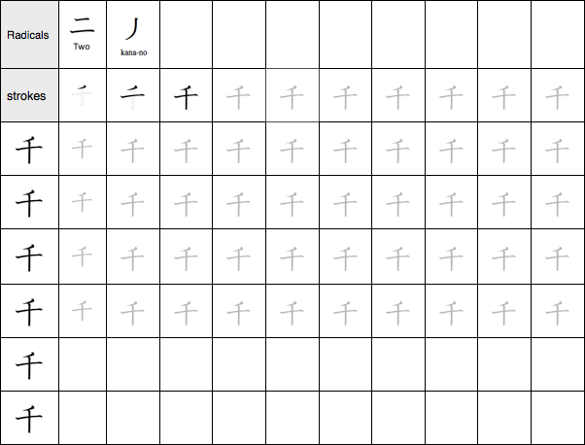

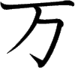
Meaning:
Onyomi: Kunyomi: Vocabulary:
Ten thousand
Man/Ban [まん/ばん]
/
万引き - まんびき - manbiki –
Shoplifting
To check the strokes order click on the link or
search www.kanjiyes.com
★ It looks like a capital T and a h combined like
in Thousand and the capital T also stands for Ten
3 strokes

